South Dakota State Fair
Timed Event Championship Rodeo

Saturday, September 4, 2021 • 10 AM
Sunday, September 5, 2021 • 10 AM
North Arena

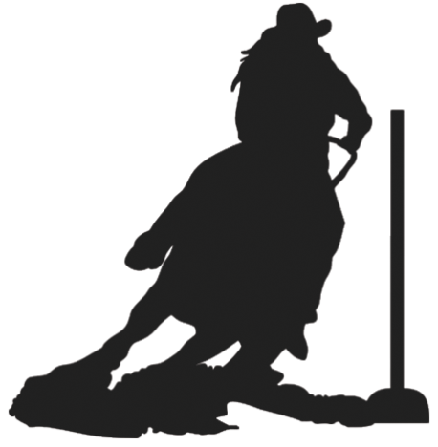

Sponsored in part by:

Double D Western Wear • Panhandle Slim
LG Seeds Farm Credit Services of America

Questions Contact: Steven Birkholtz 605.625.3437
Contact: Jason Edleman 605.350.5000

More information Visit: http://sdtimedeventchampionship.webs.com/

Entries due August 1, 2021
HEALTH PAPERS are REQUIRED

