South Dakota State Fair
Team Sorting & Penning Jackpot

Team Sorting: Wednesday, September 1, 2021 • 10 AM
Team Penning: Thursday, September 2, 2021 • 10 AM
Registration 9 AM (office closes at 9:30 AM)
North Arena
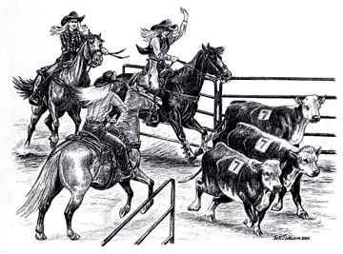
Sponsored in part by Garbe Cattle & Gravel Olinger Trucking

ADDED MONEY
$1,000 Guaranteed

Payout 60%

Entry Fee $35 per man, per run
5 Run Limit
Pick 4, Draw 1; Pick 1, Draw 4: Draw All 5
Top Money all-around earns Saddle

USTPA Rules
No Trash Rules, Fresh Beef Cattle

Questions Contact: Gary Garbe (605) 461-3924 or Clinton Olinger (605) 770-1157

HEALTH PAPERS REQUIRED
Stalls will be available in the Hippodrome
Limited camping available on west side of Hippodrome
No reservations, 1st come, 1st serve
For availability contact Della Amdahl at 605.350.0955
or in Hippodrome office the day of event.

