South Dakota State Fair
Sheepdog Trials
Hippodrome

Wednesday, September 1, 2021
9 AM - Stock Dog Clinic
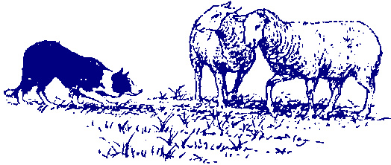

Thursday, September 2, 2021
9:30 AM - Handler’s Meeting
10 AM - Ranch, Open and Intermediate Classes
4 PM - Intermediate Finals
5 PM - Youth Agility Exhibition
6:30 PM - Open Finals

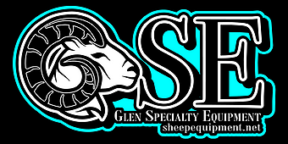
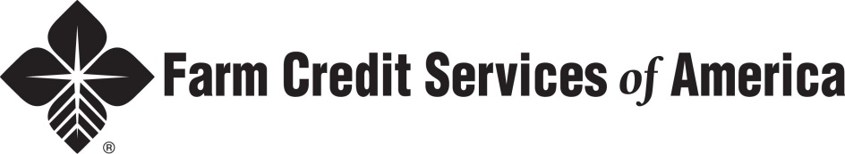
PIPESTONE LIVESTOCK AUCTION MARKET
ACE HARDWARE-MILLER AND REDFIELD
PLATTE LIVESTOCK | KIMBALL LIVESTOCK
PRANGER FEED MILL

For more contact Dale Duxbury (605) 354-2656 or ducks@santel.net

HEALTH PAPERS REQUIRED

