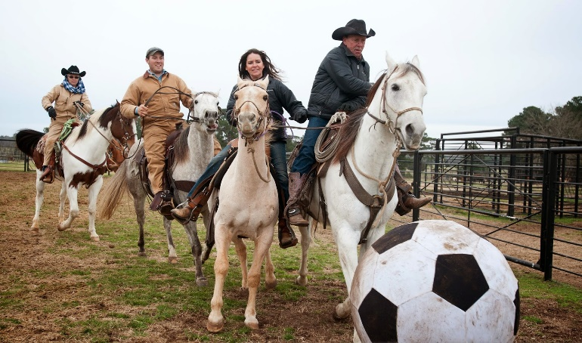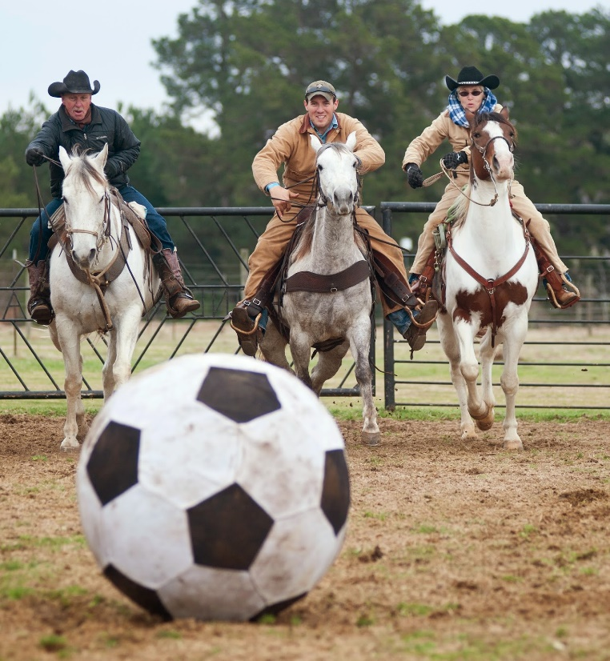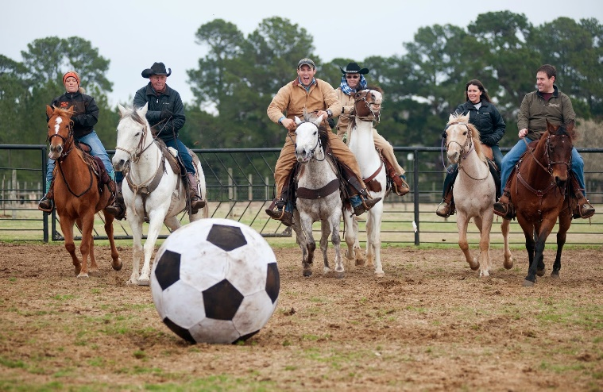

**2nd Annual Horse**

**Soccer Tournament**

SD State Fair

Saturday

Sept 4th @6pm in the Hippodrome

*Teams of three

* $20 per team

*Contact Nicki to sign up. Text or Call 605-520-3787

Cash Prizes & Trophy Tumblers