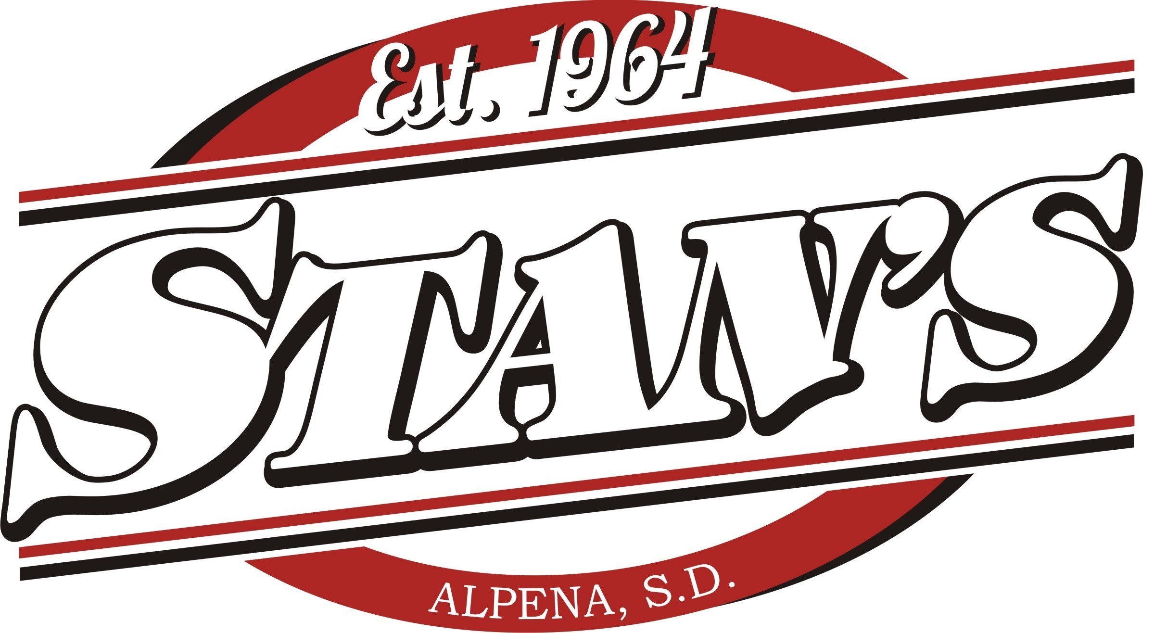
SD State Fair Antique Tractor Show sponsored by Stan’s Inc.
Sunday, September 4 | 11:00 AM – 4:00 PM
Centennial Stage – Hosted by Sherwin Linton
* Any antique tractor is eligible to enter in the tractor show.
* When arriving at the fairgrounds, please enter Gate 6. Security will direct you to the Centennial Stage where your tractor will be unloaded. If you have a trailer, State Fair Security will direct you where to park it. Following the 4:00 PM Sherwin Linton show, tractors will be allowed to leave.
Trophies awarded to 1st – 3rd place.
Awards – 4:00 PM
* Judging is done in a people’s choice format meaning that the public votes on their favorite antique tractor.
Name: ______________________________________________________
Phone Number: __________________
Mailing Address: _______________________________________________________
Make: ____________ Model: ____________________ Year: ______________
Each participant will receive two complimentary gate admission passes. All passes will be mailed out if registering before Friday, August 26. If registering after August 26, your passes will be available for pick up at Gate 6 on Sunday, September 4.
Waiver of Liability: In consideration of your acceptance of this entry form and fee, I the undersigned, intending to be legally bound, do hereby for myself, my heirs, executors and administrators, waive and release all rights and claims for damages I may have against South Dakota State Fair 2022, South Dakota State Fair, their agents, successors and assigns for any and all injuries suffered to me in this event. I further grant permission to South Dakota State Fair and/or agents authorized by them, to use any photographs, videotapes or any other record of this event for legitimate purposes.

Signature: __________________________________________ Date: ___________

