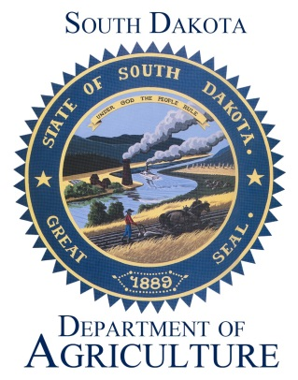
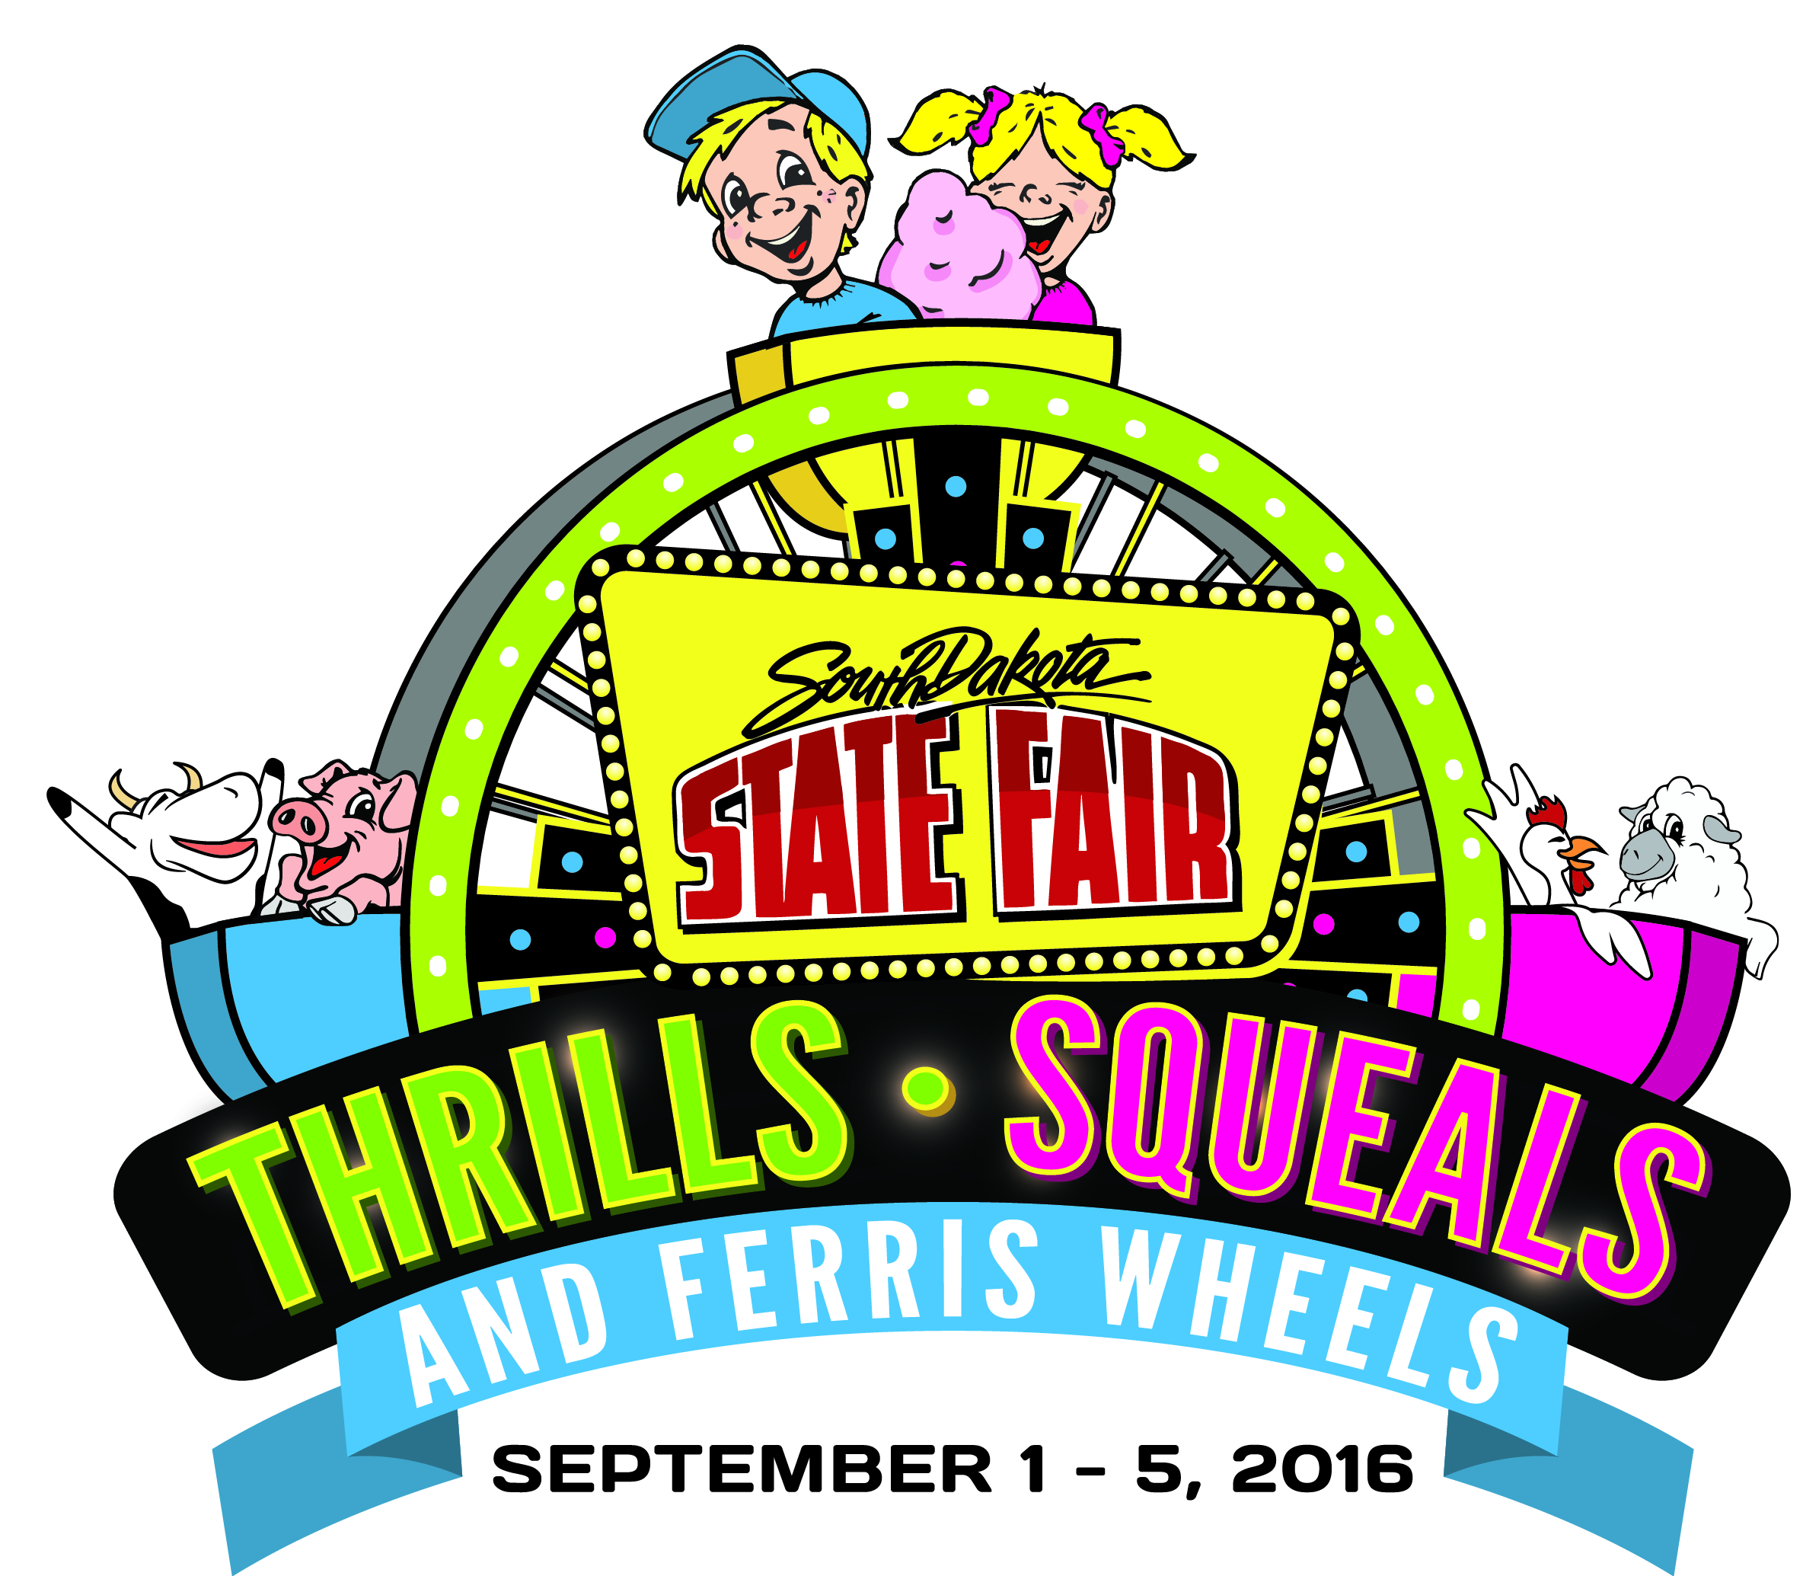
SOUTH DAKOTA DEPARTMENT OF AGRICULTURE
NEWS RELEASE

For Immediate Release: June 30, 2016
Media Contact: Candi Briley, (605) 353-7340

Education in Spotlight at the State Fair

(Huron, SD) – Every year teachers are encouraged to submit student education entries to the Education Department in the Arts & Education Building at the South Dakota State Fair. For some teachers, it’s a tradition. For others, it’s their first time submitting.

This year, 93 teachers submitted 5,038 entries compared to 78 teachers submitting 4,578 entries in 2015.

“We are very excited about the increased number of entries this year in the education department! In the last couple years, we have made changes to the education static book in response to teacher requests and changing student goals/expectations in the classroom. We have also worked to get the education static book in educators’ hands sooner so that entries can be incorporated into lesson plans the entire school year, not just second semester when the static book was available in the past. We saw a number of teachers take advantage of the printed static books available during the 2015 event and make notes as they viewed the exhibits,” said Mary Helen Wipf, education superintendent. “We want to say ‘thank you’ to the 93 teachers who have made the extra effort to submit their students’ classroom projects. We wish the teachers could see and hear what staff and volunteers hear when students see their entry displayed at the South Dakota State Fair.”

“This increase in entries is exciting news,” said State Fair Manager Peggy Besch. “The Arts & Education Building offers such a diversified array of educational displays while also showcasing the talents of South Dakotans. This growth is just one more strong indication there is a lot of interest and value in participating in the programs offered. We are thrilled to see the participation increase.”

Deadlines for all other South Dakota State Fair open class entries are coming up quickly. The static entry deadline is Friday, July 31. Entries postmarked on that day will be accepted. Remember to include payment and completed W9 form (include SSN) with your entry. The open class livestock entry deadline is Saturday, Aug. 1. Late fees will apply to entries received after the deadline.
Premium books are available online at www.sdstatefair.com.
The 2016 South Dakota State Fair will run from Thursday, Sept. 1, through Monday, Sept. 5. Channel Seeds Preview night will be Wednesday, Aug. 31. This year’s theme is “Thrills, Squeals and Ferris Wheels.” For more information on State Fair events, contact the Fair office at 800-529-0900, visit www.sdstatefair.com or find them on Facebook or Twitter.
Agriculture is a major contributor to South Dakota’s economy, generating $25.6 billion in annual economic activity and employing over 115,000 South Dakotans. The South Dakota Department of Agriculture's mission is to promote, protect, preserve and improve this industry for today and tomorrow. Visit us online at http://sdda.sd.gov or find us on Facebook, Twitter and Instagram.

-30-

